Title of Activity:
Guest Lecture On Green Building Design: Net Zero Buildings-An Overview And True Impact
Description:
Ar. Sarly Adre Sarkum addressed B.Tech Students on Guest Lecture On Green Building Design: Net Zero Buildings-An Overview And True Impact. This lecture covers an all the points required for the sustainable and net zero energy building design and practices, green building council and green rating system. His lecture emphasis on green architecture and its need, embodied energy.
Date Of Activity: 11-02-2021
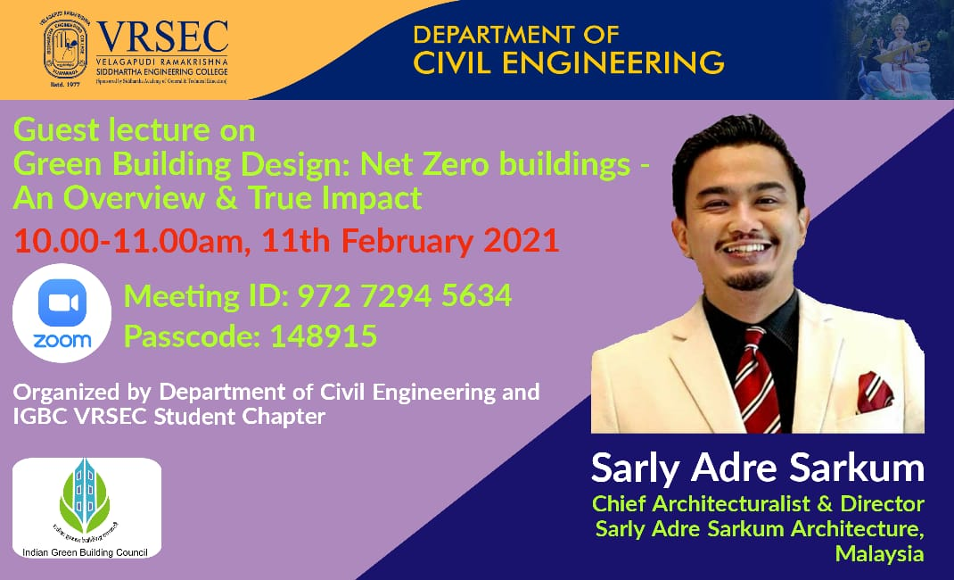 | 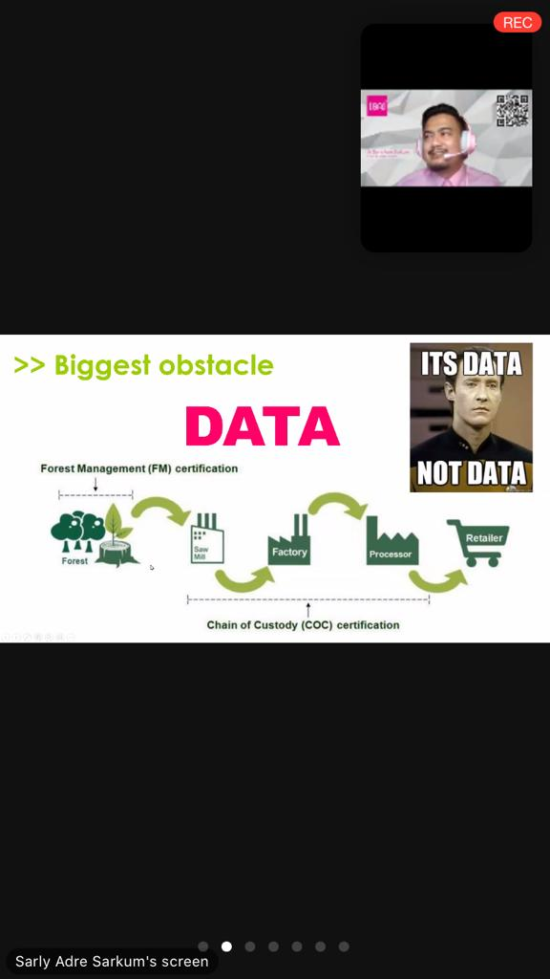
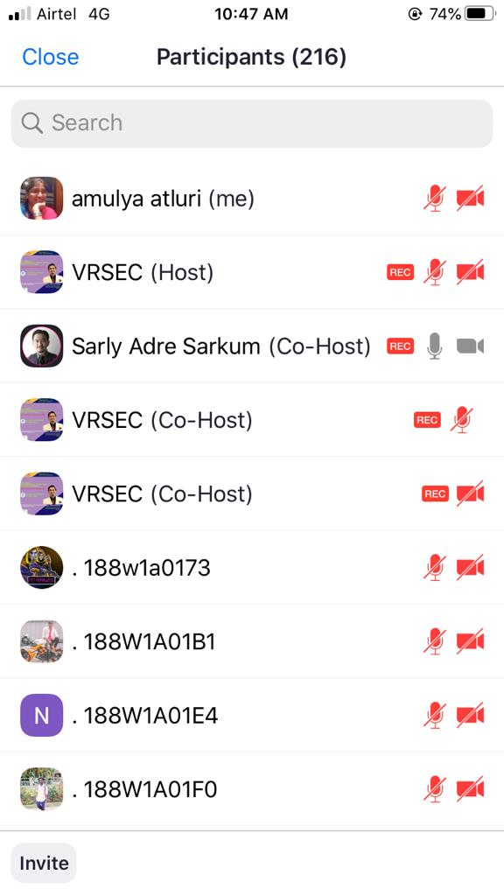 | 