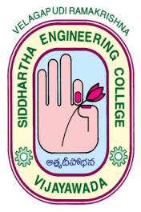
CIVIL ENGINEERING DEPARTMENT
VELAGAPUDI RAMAKRISHNA
SIDDHARTHA ENGINEERING COLLEGE
(Sponsors: Siddhartha Academy of General and Technical Education)
VIJAYAWADA- 520007

Speaker’s name & Designation | AR.SHIVA MOHAN.K-FOUNDER, SCALE DESIGNS  MR.VEERESH-M.D,ESVE DESIGN SOLUTIONS
Date and time of lecture | 19-june 2021, 10:00 am to 1:00 p.m.
Title | FUTURE SUSTAINABLE BUILDINGS-INTEGRATED DESIGN APPROACH (Organized by IGBC-VRSEC)
Beneficiaries | 3rd,4th year civil and mechanical engineering students
Faculty attended | All Civil engineering and mechanical faculty
Highlights | IGBC student chapter-VRSEC in collaboration with ISHARE Vijayawada conducted a half-day workshop on future sustainable buildings-integrated design approach. IGBC Amaravati chapter chairman Mr. Vijay saiMeka addressed and spoke about importance of green buildings and sustainable approaches in construction.Ar.shivamohan gave a nice perspective on sustainable building materials and implementation of sustainable design and its inclusion at design phase itself. M.Veeresh spoke about MEP designs of tall buildings and MEP software and applications. The session received good response and feedback
Photos | 