DEPARTMENT OF CIVIL ENGINEERING
V R SIDDHARTHA ENGINEERING COLLEGE
Guest lecture Report
Event | Webinar on “Career Guidance for B.Tech CE students”
Guest speaker | Mr D Hari (Alumni) & Mr D Pavan Kumar (Alumni)  Dy Engineer,  BHEL, Machilipatnam
Date | 03.07.2020
Beneficiaries | B.Tech Students(60)
Faculty attended | Dr Chava Srinivas, Sri S Satish, Sri Haroon Ali Khan, Sri Ch Raviteja
Highlights | Speakers addressed UG students regarding various opportunities after graduation. Skill attributes required for different organizations. Discussed opportunities in different government and private sector units. Addressed works going on at BHEL and sequence of operations to be taken place in construction. Discussed importance of planning in construction.
Photos | 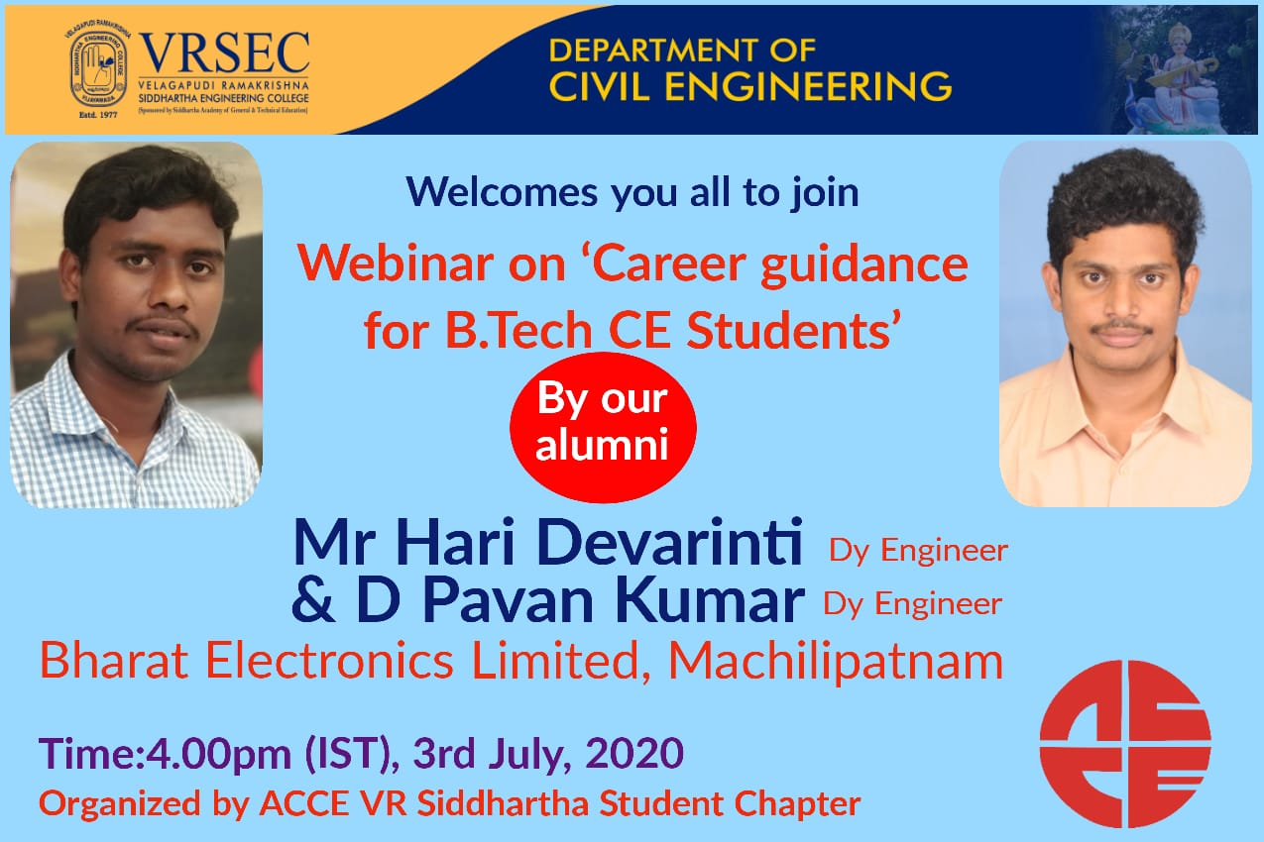
 | 