Velagapudi Ramakrishna
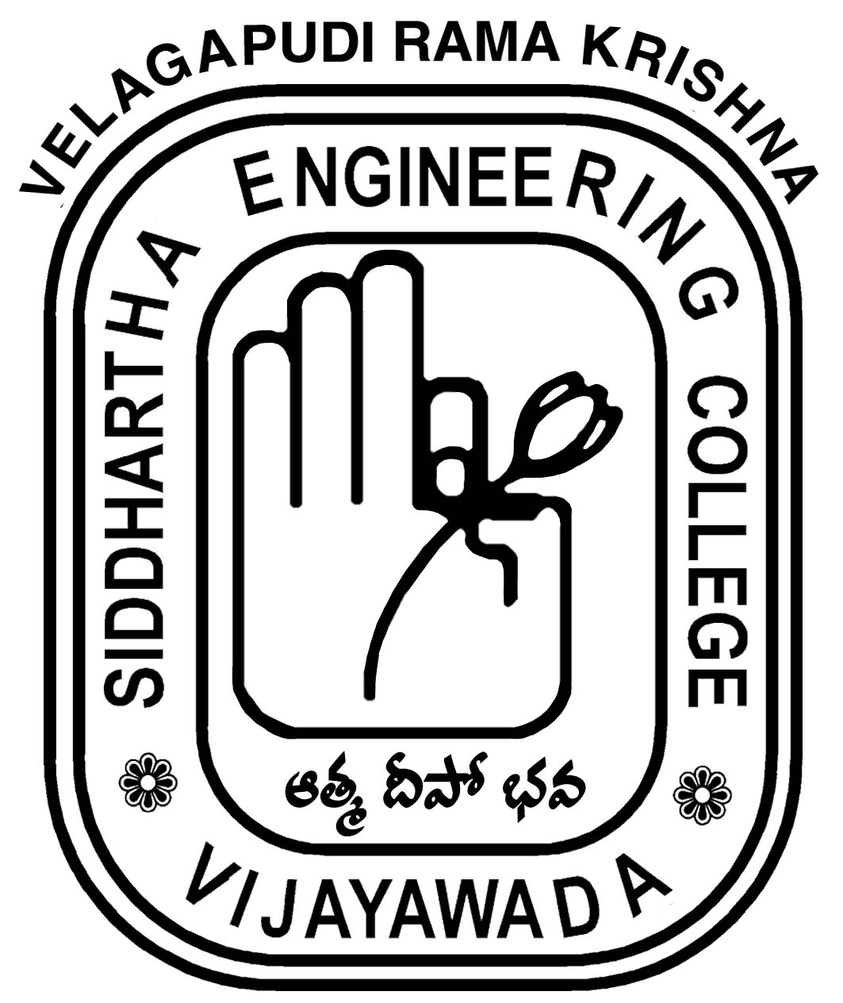
SIDDHARTHA ENGINEERING COLLEGE
(Autonomous)
Vijayawada – 520 007, Andhra Pradesh

INTERNAL QUALITY ASSURANCE CELL (IQAC)
The Internal Quality Assurance Cell (IQAC) of V.R. Siddhartha Engineering College, Vijayawada in association with Learning and Development Centre, SRMIST, Chennai was organized a 3 day Faculty Development Programme on “Scientific Educational Practices” during 17th – 19th March, 2022 at M.Tech., Computer Lab. – I ( Room No. 128), Department of Computer Science and Engineering, V.R. Siddhartha Engineering College, Vijayawada.
The various Professional personalities associated with the programme are as follows:
Prof. Rajeev Sukumaran, Resource Person, SRMIST, Chennai.

Dr. Christraj M.R, Resource Person, SRMIST, Chennai

Dr. M.V.S. Raju, Coordinator, IQAC and Dr. V. Mallikarjuna, Associate Professor, Department of Civil Engineering, V.R. Siddhartha Engineering College have been acted as Coordinators of the FDP.

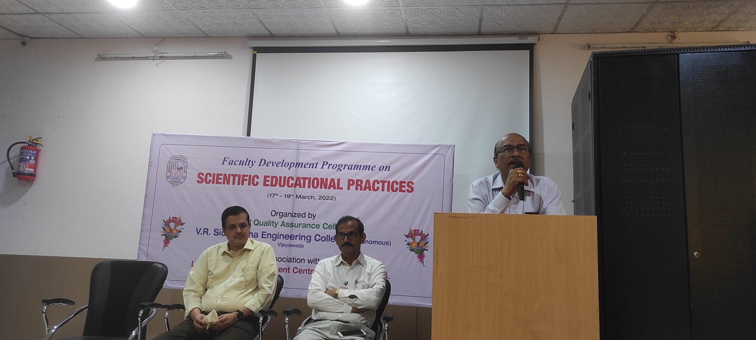
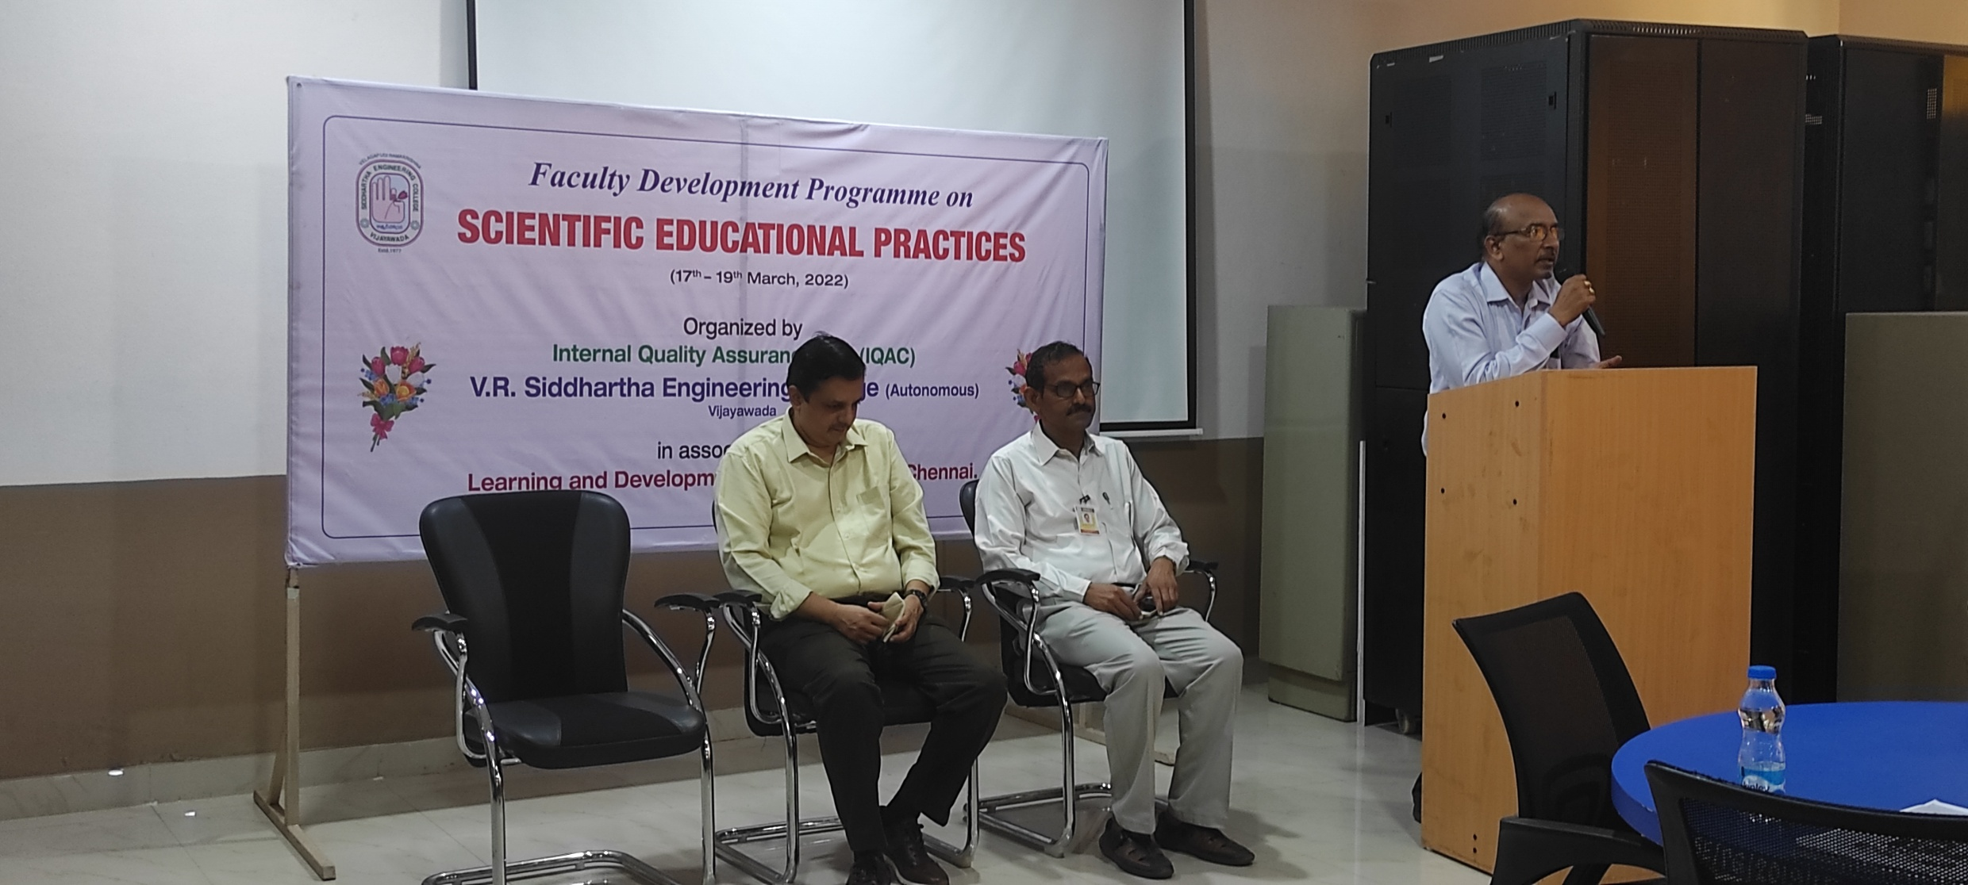
Thirty nine participants from various departments of V.R. Siddhartha Engineering College Vijayawada attended the said programme.
The Programme covers the various modules with respect to various Scientific Educational Practices. The modules covered in the technical sessions are as follow:
- Taxonomy of Learning - Psychomotor
- Identifying thinking styles – Thinking Process Model
- Classification of Scientific Knowledge
- Learning Styles – Active Learning and Components
- Course Syllabus and Plan of Execution
- Institutions good practices in bringing ‘Positive Behavior’
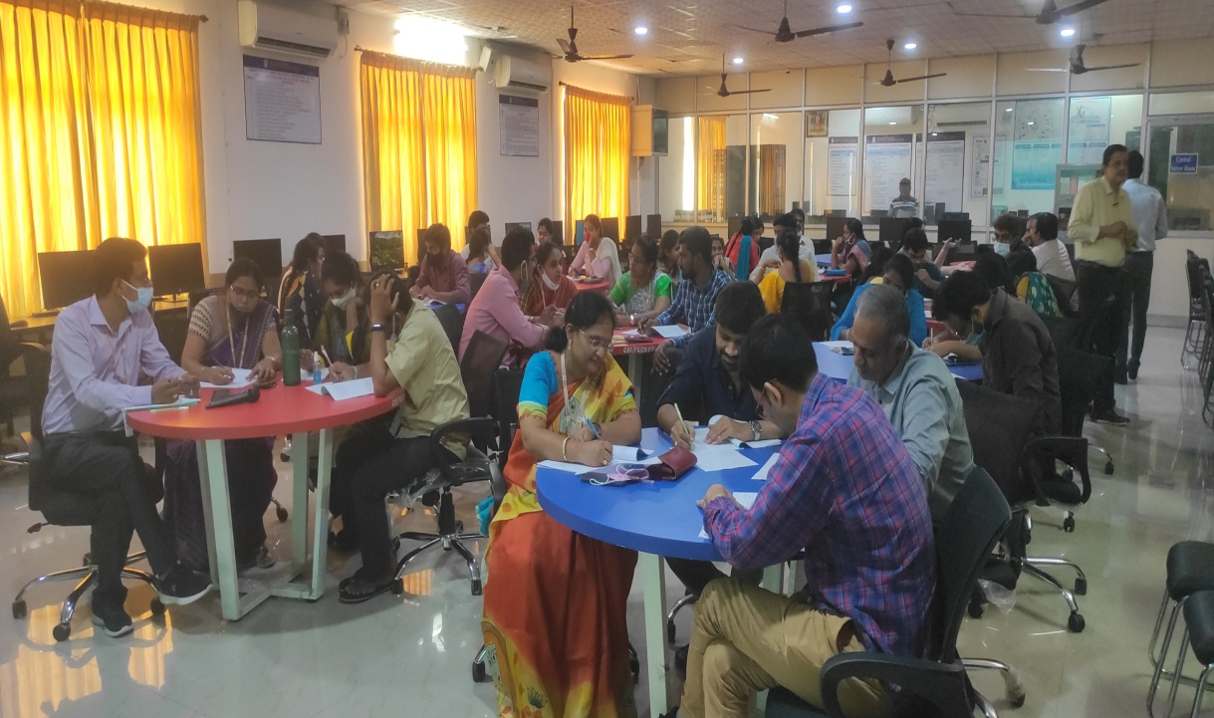
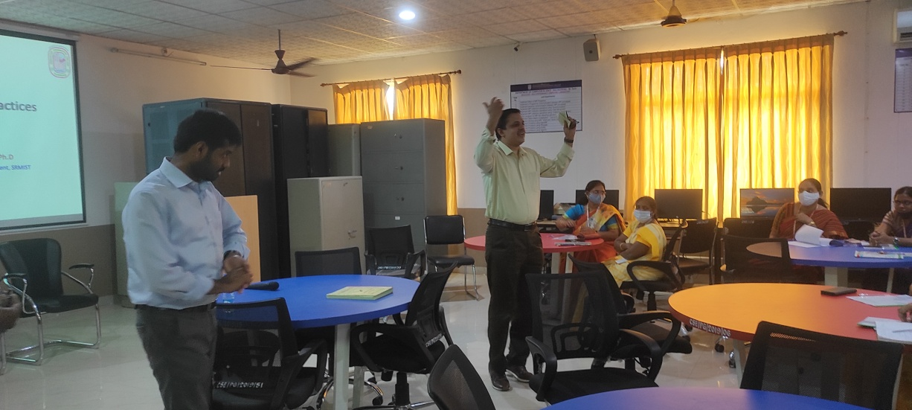
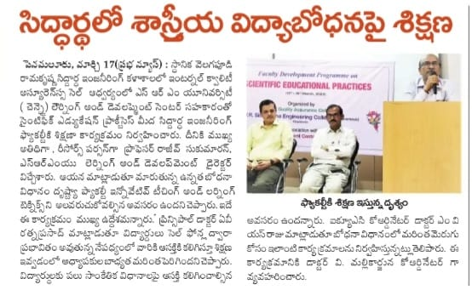
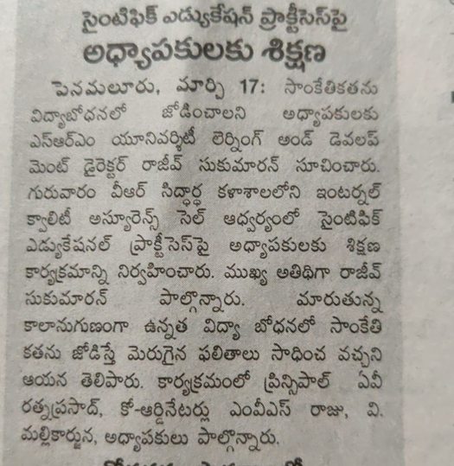

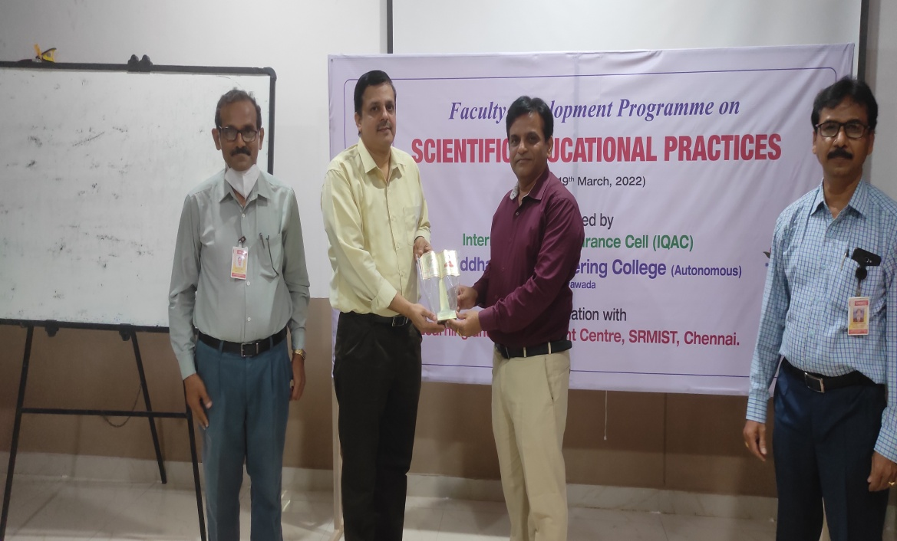

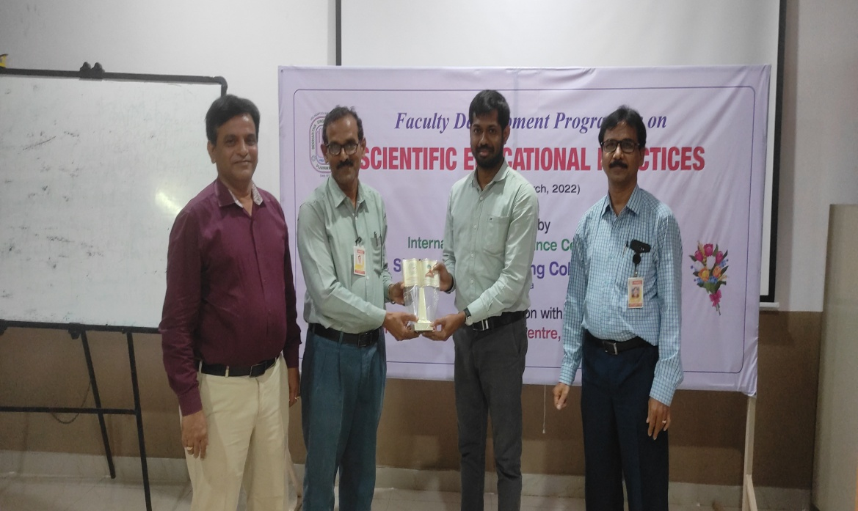
The programme was suitably organized to enhance the abilities with respect to adopt and to practice various scientific educational methods in Outcome Based Education System. The programme was ended up with closing remarks by Dr. M.V. S. Raju, Coordinator, IQAC and Dr. Ch. Rajeswara Rao, HOD, CSE, V.R. Siddhartha Engineering College, Vijayawada.

Dr. V. Mallikarjuna Dr. M.V.S. Raju
Coordinator, FDP Coordinator, IQAC

