INTERNAL QUALITY AND ASSURANCE CELL (IQAC)
REPORT ON A FIVE DAY FACULTY DEVELOPMENT PROGRAMME
“DESIGN THINKING”
Under AICTE MARGDARSHAN
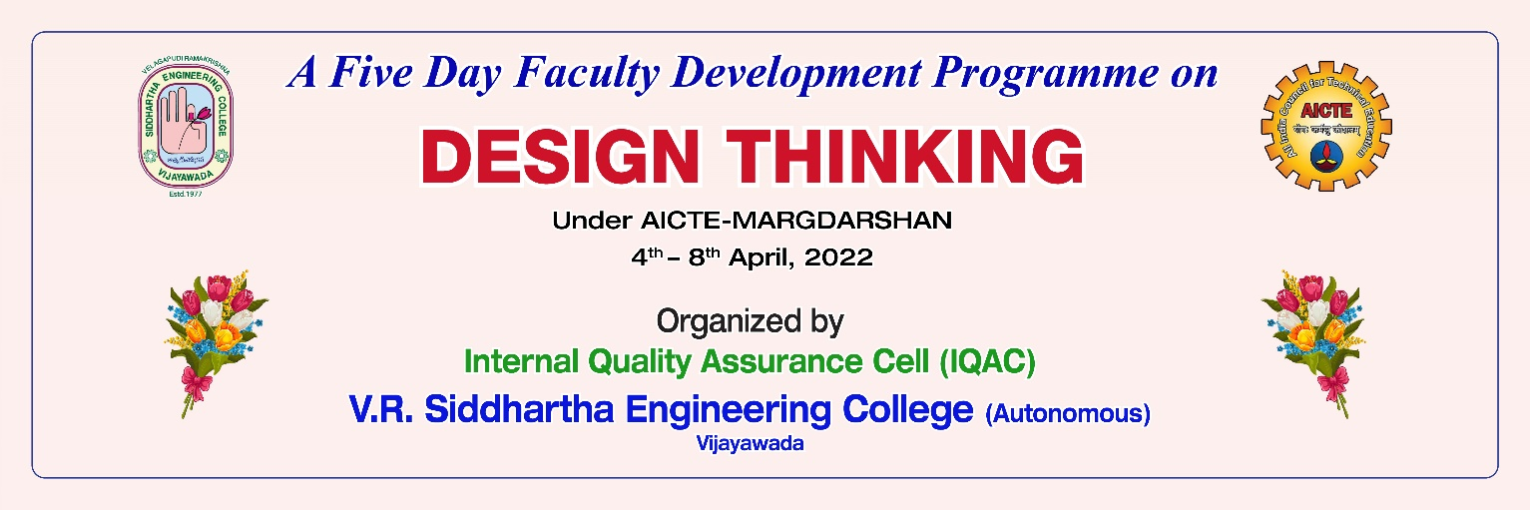
Resource Person:
Dr. Bala Ramadhorai
Author – Karmic Design Thinking,
International Visiting Professor, Consultant

Design thinking is a process for solving problems by prioritizing the consumer's needs. It relies on observing, with empathy, how people interact with their environments, and employs an iterative, hands-on approach to creating innovative solutions. The short form of the design thinking process can be articulated in five steps or phases: empathize, define, ideate, prototype and test. One of the methodology in design thinking is TRIZ where it draws on the past knowledge and ingenuity of thousands of engineers to speed up creative problem solving for project teams. Iterates through the various stages, revisiting empathetic frames of mind and then redefining the challenge as new knowledge and insight is gained along the way.
Day 1: Introduction to Karmic Design Thinking and team formation
He explained the 5 steps of Design Thinking Process
Empathy: The first stage of the Design Thinking process is to gain an empathic understanding of the problem you are trying to solve. This involves consulting experts to find out more about the area of concern through observing, engaging and empathizing with people to understand their experiences and motivations, as well as immersing yourself in the physical environment so you can gain a deeper personal understanding of the issues involved.
Define: During the Define stage, you put together the information you have created and gathered during the Empathise stage. This is where you will analyse your observations and synthesise them in order to define the core problems that you and your team have identified up to this point.
Ideate: During the third stage of the Design Thinking process, designers are ready to start generating ideas. You’ve grown to understand your users and their needs in the Empathise stage, and you’ve analysed and synthesised your observations in the Define stage, and ended up with a human-centered problem statement.
Prototype: The design team will now produce a number of inexpensive, scaled down versions of the product or specific features found within the product, so they can investigate the problem solutions generated in the previous stage. Prototypes may be shared and tested within the team itself, in other departments, or on a small group of people outside the design team.
Test: Designers or evaluators rigorously test the complete product using the best solutions identified during the prototyping phase. This is the final stage of the 5 stage-model, but in an iterative process, the results generated during the testing phase are often used to redefine one or more problems and inform the understanding of the users, the conditions of use, how people think, behave, and feel, and to empathise
He formed groups among all the participants
Day 2: Empathize - Customer journey mapping
Customer journey maps are used to map the relationship between a customer and an organization over time and across all channels on which they interact with the business. Design teams use customer journey maps to see how customer experiences meet customers' expectations and find areas where they need to improve designs.
Sir asked all the participants to take their own problems and design the customer journey mapping with Before, During and After as the attributes.
He asked to mail each one of them and discussed about the problems taken by all the teams in terms of customer journey mapping.
Day 3: Analyze - Multi-Whys
The aim of the method is to raise awareness of a specific problem or situation. The aim is to achieve a holistic understanding of why processes do not achieve the desired results and where changes need to be made.
Sir asked to prepare 5 Whys for all the problems i.e., how might we (HMW) questions are to be added.
Day 4: Solve - Ideation and TRIZ
He discussed about the possible solutions are by using TRIZ methodology for all the HMW questions which are given by all the teams.
TRIZ, also known as the theory of inventive problem solving, is a technique that fosters invention for project teams who have become stuck while trying to solve a business challenge. It provides data on similar past projects that can help teams find a new path forward.
Day 5: Test and Wrap up
Sir asked all the teams to consult one person and to discuss about the problems he faced in the working hours of their occupations.
Sir has given a template of PPT and asked all the team mates to describe the customer journey map along with HMW questions and to give what are the feasible solutions for the problems being faced by that person.
All the teams interacted with sir and discussed the customer journey map.

